**V. I .R.**

Current is directly proportional to electric potential difference and **inversely proportional** to resistance.

**the current is the flow of electric charges**. **the potential difference provides the 'push'** **the resistance restricts the flow of charges**.

**To distinguish between current, voltage, and resistance, their basic definitions are given below:**

* **Current** refers to the amount of charges that flow in any part of the conductor per time interval.
* **Voltage** is a measure of the potential difference between two points. It is applied across a wire or an electric component. A source of voltage, for example, is battery and is used to maintain a potential difference in the circuit but not to supply current.
* **Resistance** is the measure of the opposition to the current in a circuit.

**units**

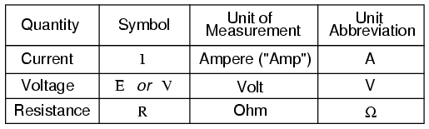

**convential and electron current.**

The flow of electrons is termed electron current. Electrons flow from the negative terminal to the positive. Conventional current or simply current, behaves as if positive charge carriers cause current flow. Conventional current flows from the positive terminal to the negative.

### Conventional Flow Notation

However, because we tend to associate the word “positive” with “surplus” and “negative” with “deficiency,” the standard label for electron charge does seem backward. Because of this, many engineers decided to retain the old concept of electricity with “positive” referring to a surplus of charge, and label charge flow (current) accordingly. This became known as conventional flow notation:

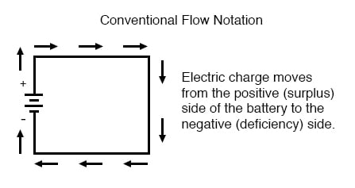

### Electron Flow Notation

Others chose to designate charge flow according to the actual motion of electrons in a circuit. This form of symbology became known as electron flow notation:

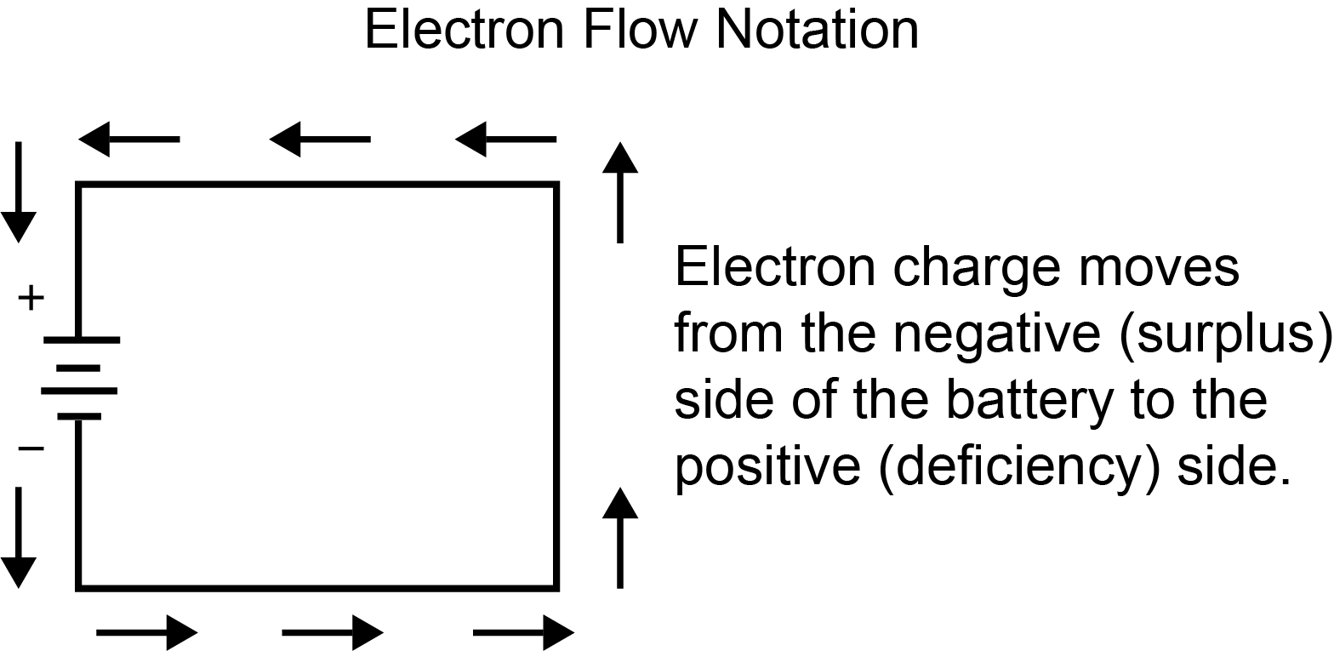

In conventional flow notation, we show the motion of charge according to the (technically incorrect) labels of + and -. This way the labels make sense, but the direction of charge flow is incorrect. In electron flow notation, we follow the actual motion of electrons in the circuit, but the + and - labels seem backward. Does it matter, really, how we designate charge flow in a circuit? Not really, so long as we’re consistent in the use of our symbols. You may follow an imagined direction of current (conventional flow) or the actual (electron flow) with equal success insofar as circuit analysis is concerned. Concepts of voltage, current, resistance, continuity, and even mathematical treatments such as Ohm’s Law (chapter 2) and Kirchhoff’s Laws (chapter 6) remain just as valid with either style of notation.

